Greetings from Millington,

LCDR Mays Opening Remarks:

Good morning and welcome to the March OP Drumbeat TEAMS series. This month we have a presentation on accession programs, presented by CDR Adam Hilliard and LTJG Max Collins along with Q&A. Before we start we have some announcements:

1. Due to Continuing Resolution concerns, Puget Sounds and Pearl Harbor Roadshow have moved from March to May. Specific dates/times have been sent out to the roadshow AOs for each location. Please reach out to the AO for any questions or concerns and we look forward to seeing you on the road.

2. PG Board – Starts 9APR25, CIVINS Packages are due 28MA2025.

3. TWI Board – Starts 21APR 25, please read flash for detailed specific on the board.

Speakers: CDR Hilliard and LTJG Max Collins

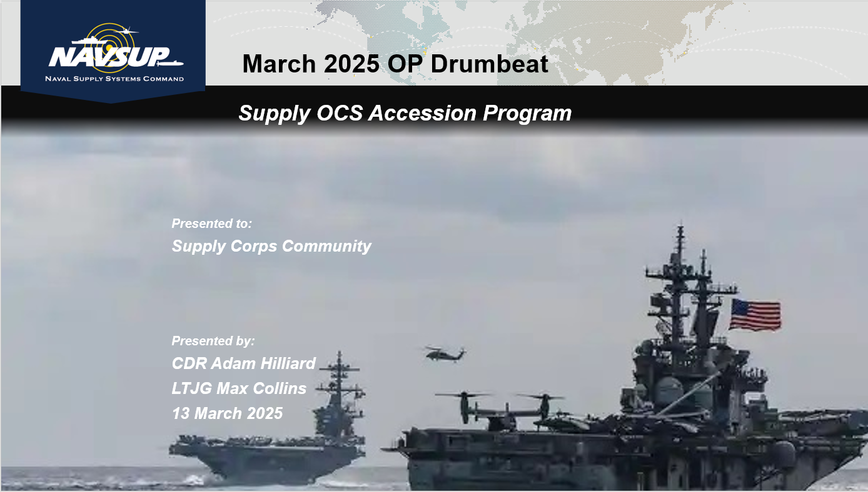

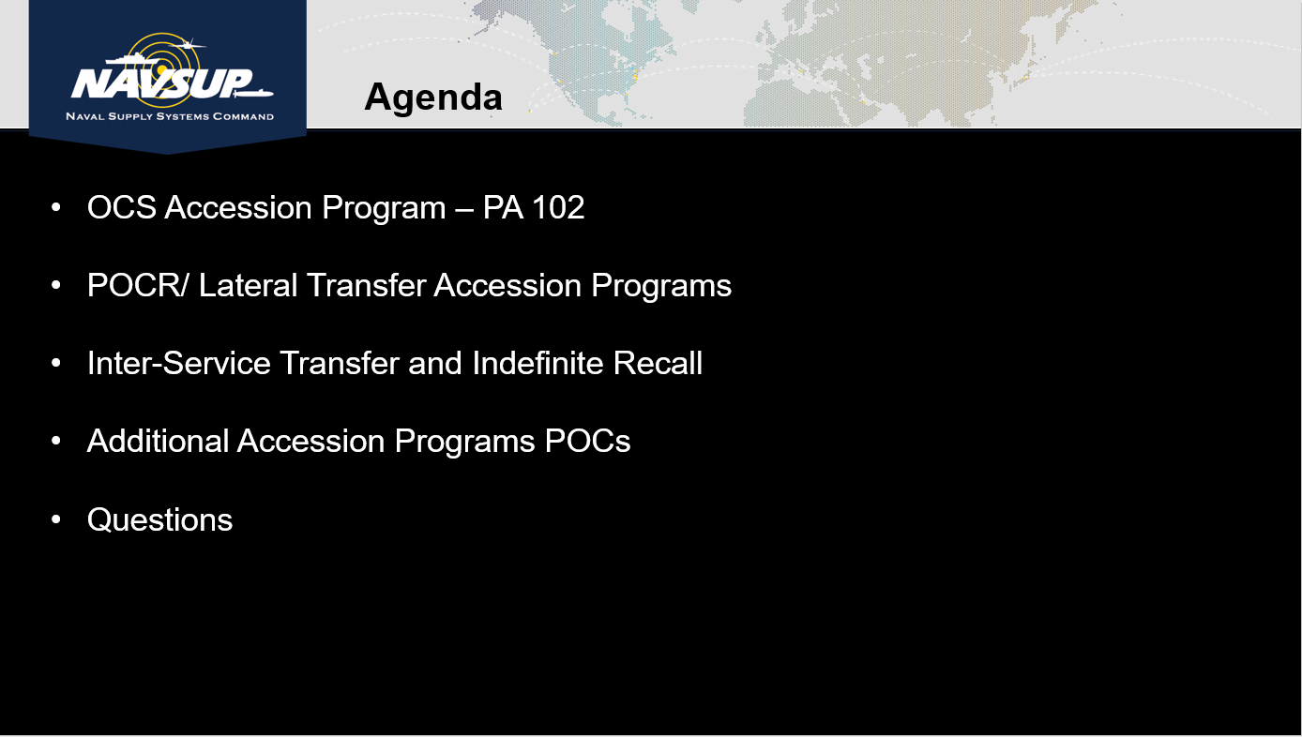

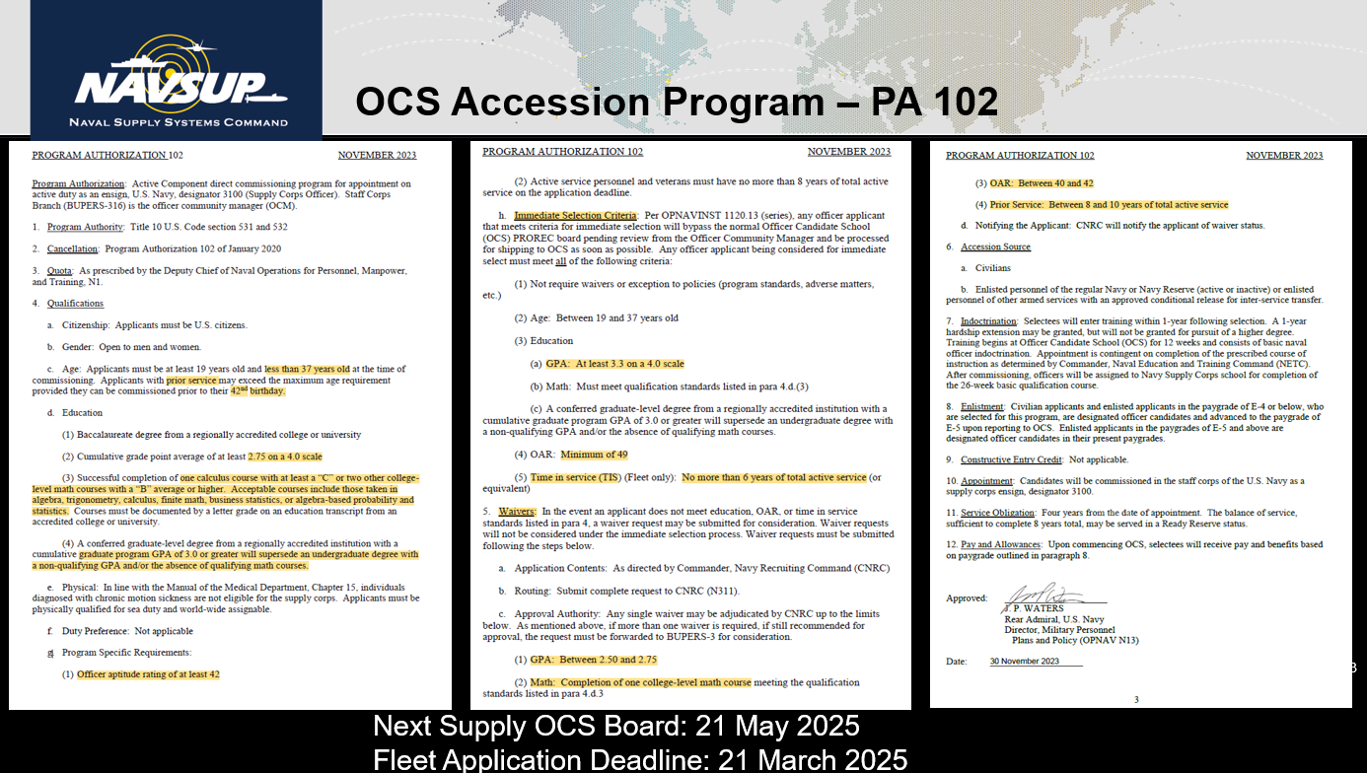

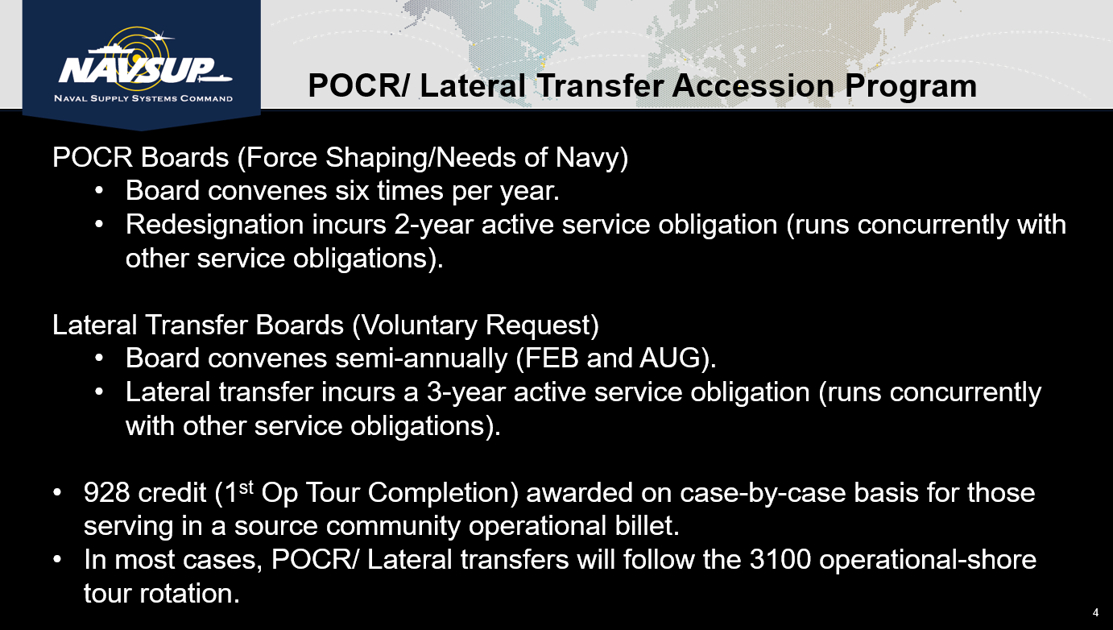

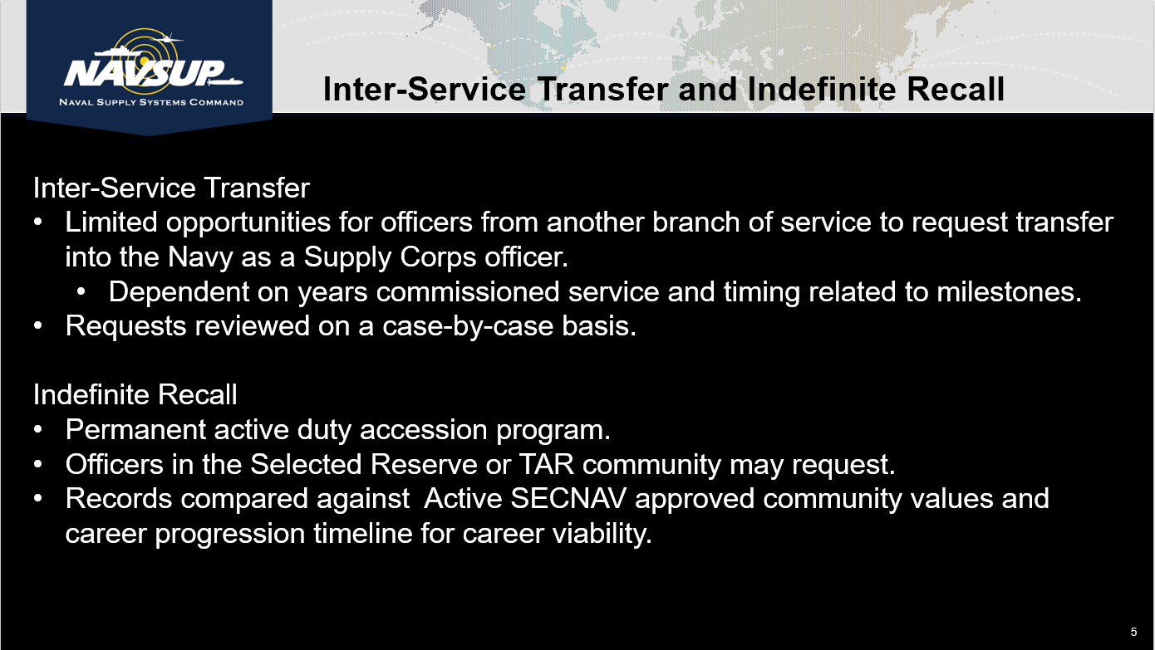

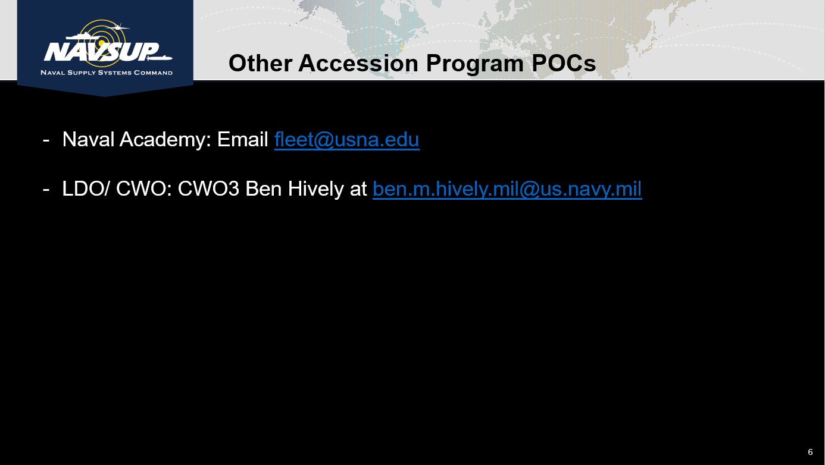

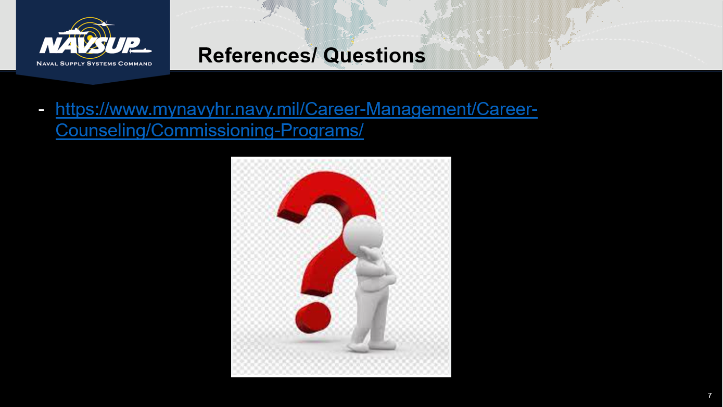

_____________________________________________________________________________________

Q & A Session:

Q1. Chat Question: Are potential candidates automatically screening for the Immediate Selection Criteria?

A1. CDR Hilliard: The process should be automatic but make sure the candidate knows to bring it up with their recruiter. Most recruiters know about the program and help but there are some who may fail to mention it.

Q2. Chat Question: How much weight is given to interview appraisals and if they come from a Supply Officer?

A2. CDR Hilliard: When the package is graded it is graded in its totality. Appraisals done by O6 Supply officers carry pretty heavy weight in the review process. The appraisals don’t necessarily have to come from a Supply Officer but those that come from more senior officers are better for the candidate.

Q3. Chat Question: Are MEPs MED waivers already adjudicated for approval prior to the waiver process?

A3. Yes, med waivers are adjudicated before the board and is not something the board takes into consideration. Med waivers are usually not even in the package being reviewed.

_____________________________________________________________________________________

Important Links:

[Commissioning Programs](https://www.mynavyhr.navy.mil/Career-Management/Career-Counseling/Commissioning-Programs/)

[Fleet Officer (OCS) Application Checklist](https://www.mynavyhr.navy.mil/Portals/55/Career/CareerCounseling/Fleet%20Officer%20(OCS)%20Application%20Checklist.pdf?ver=DxQTq4EXfJplW33VLJyCqA%3d%3d)

[Supply Corps OCS Program Authorization (PA 102)](https://www.mynavyhr.navy.mil/Portals/55/Career/OCM/PA-102_SC_Officer_Nov-2023%20.pdf?ver=Hww3vFxXfce3H8Gnq6VrAQ%3d%3d)

[Supply Corps OCS Guide for Commanding Officers and Mentors](https://www.mynavyhr.navy.mil/Portals/55/Career/Detailing/Officer/StaffCorps/Supply/Supply%20Corps%20OCS%20Guide%20for%20COs%20and%20Mentors.pdf?ver=fMa9atKIVj-IPnFS5v1ySA%3d%3d)